Youth & Community Services Supervisor Report
Youth Commission
(December 13, 2023)

- Counseling Updates

The Youth and Community Services Division is responsible for the coordination of a comprehensive community-based youth services bureau and the delivery of essential life services for Bristol residents in need. The Bureau strives to enhance the networking and support between family, school, peer, and community environments. Direct services include juvenile diversion programming, individual and family counseling, crisis support and positive youth development opportunities
This report is being generated to reflect data for individual and Family Counseling, Intakes and Referrals:
- Number of intakes conducted by staff: 13 (November/December)
- Number of clients currently receiving services: 12 (Full-time staff and Contractors)
- Number of families referred by the BOE: 18 ( Positive Youth Development Groups)
- Number of families referred for (FWSN) Families With Service’s Needs:

Community Services and the Parent and Child Program:
- Intakes (November/December) Basic Needs (22), Relocation(6), Evictions (22) and Foreclosures (14)
- Intakes for the caring closet (November/December) (24)
- Holiday Gift Giving (451 as of 12/6/2023)

2023/2024 JRB Board Members
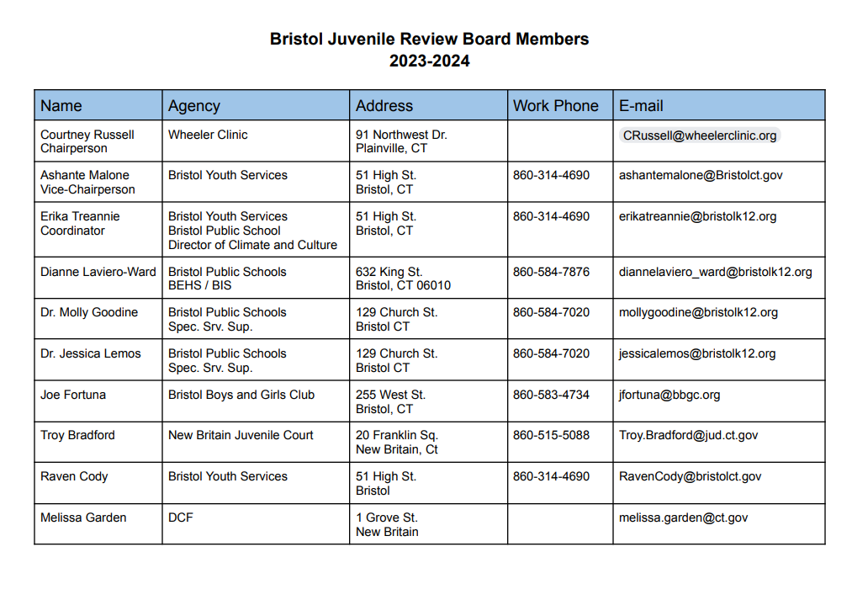
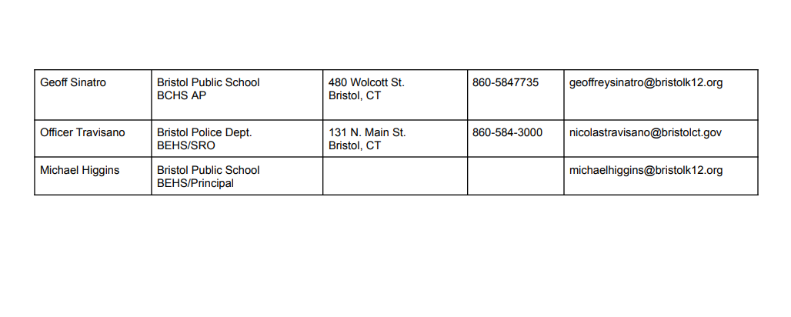

Current Juvenile Review Board Statistics:
- We currently have 13 open cases

Open Cases:
Charge | Number of Cases
Breach of Peace 2nd | 7
Criminal Mischief | 1
Disorderly Conduct | 2
Larceny 6th  Assault  Assault, Threat, Interfering  Disorderly Cond. / Trespassing | 2  1  1,1,1  1

Pending Cases: 5 Upcoming Cases
Charge | Number of Cases
Assault 3 | 1
Motor Vehicle | 1
BOP | 2
BOP Criminal Trespass | 1

Total Gender for open cases
Female | 7
Male | 6

BEST
- Mike gave two QPR suicide prevention trainings to employees at ESPN on November 1st. ESPN is looking to continue to work together.
- Mike is working individually with students, who have been caught using substances, at Bristol Central High School and Bristol Eastern High School. It is the 4-session Life Skills program. The program is also being conducted at West Bristol with 4 others students in groups of two. It is being conducted at Bristol Prep in a group of about 7. Chippens Hill Middle School has reached out and is also looking to have the program in the school in January 2024.
- Current projects include liquor seals to be given out, “cost of vaping” posters to be put in the school bathrooms, Ditch the Vape lock boxes for schools and an internet marketing campaign to curtail vaping.
- BEST donated $3,000 to Central and Eastern for grad parties. BEST also donated gym equipment to Bristol Prep.
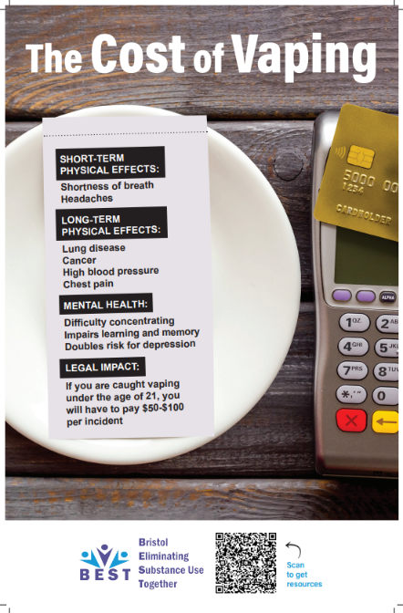
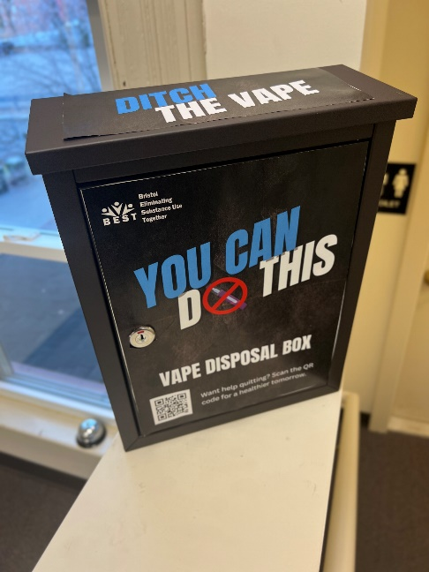
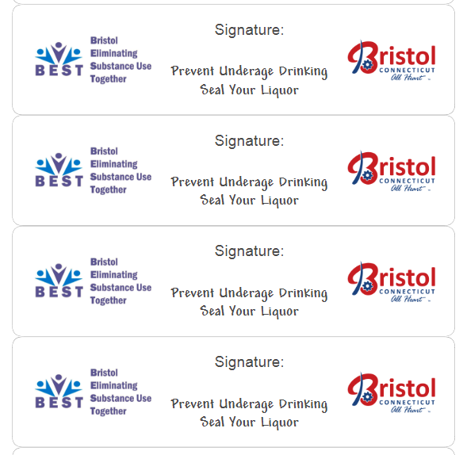

Project AWARE Program Updates
Girls with Goals
- The Girls with Goals program is up and running at both Bristol Central High School and Bristol Eastern High School!
- At BCHS, there are 7 freshman girls participating in the group. So far, topics covered have been social media, self-image, healthy relationships, mental health, and conflict/conflict resolution. It was arranged for a guest speaker from Prudence Crandall to come and present on healthy relationships, including what red flags can look like. The group is projected to end on December 20th, 2023.
- At BEHS, there are 8 students that have consistently participated in our Girls with Goals Group and have covered the aforementioned topics. The group hosted at Eastern is scheduled to end on December 18th, 2023
- By offering these groups, students have been able to share their personal experiences and struggles in a safe space.
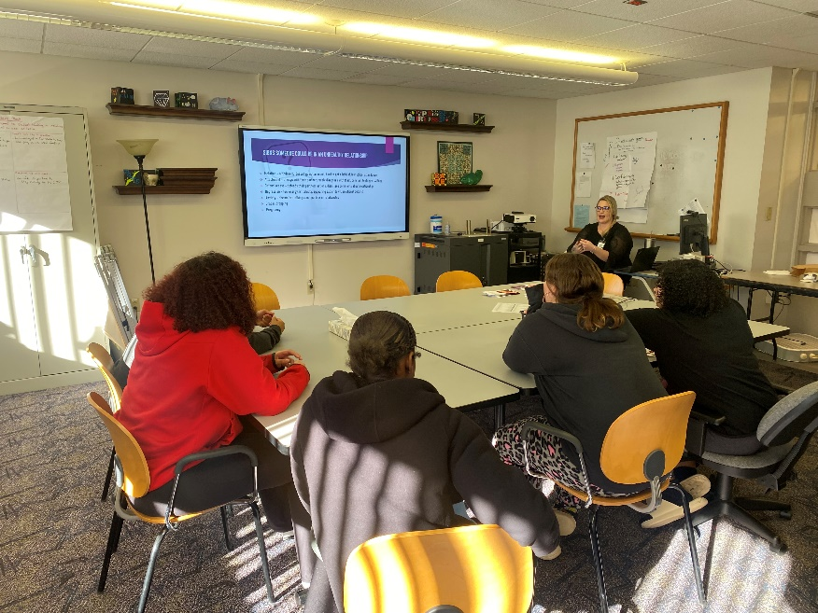

Leaders in Learning
- Leaders in Learning is a lunch bunch program that is taking place at South Side Elementary School. This program has 11, 4th grade female students participating. Lessons/activities done so far include empathy, kindness, communication, teamwork, perseverance, and decision making. Both facilitators have created strong relationships with students and are looking forward to seeing them continue to grow into leaders in their school and community.

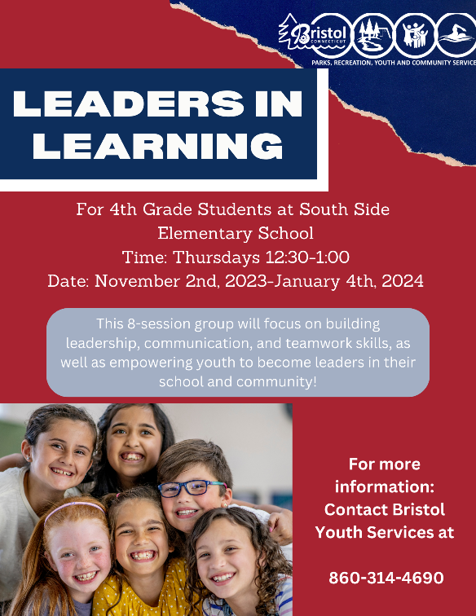

Tomorrow’s Leaders Today
- Tomorrow’s Leaders Today is in full swing at both Northeast Middle School and Chippens Hill Middle School. This program takes place 3 times a week for the duration of 2 hours each day, with Youth and Community Services Staff facilitating the 4-5pm portion each day. Staff have created and implemented many different fun teamwork, leadership, and communication activities, and are looking forward to implementing more guest speakers and field trips until the end of the program in May.

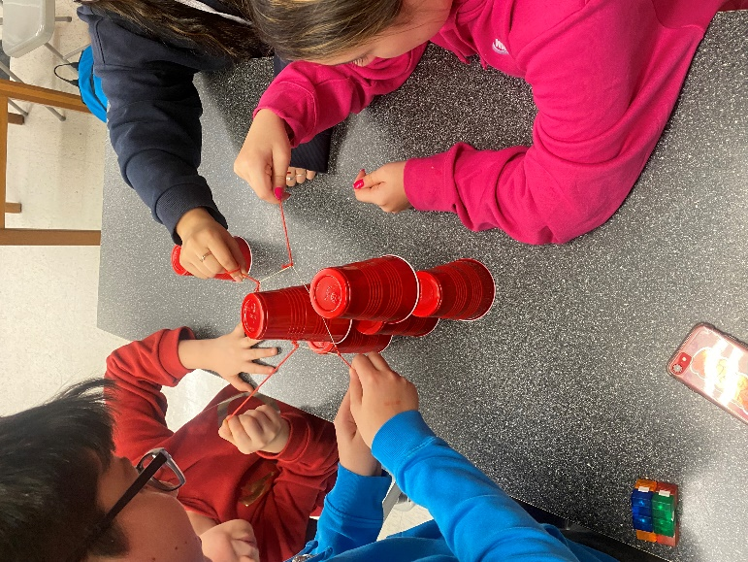

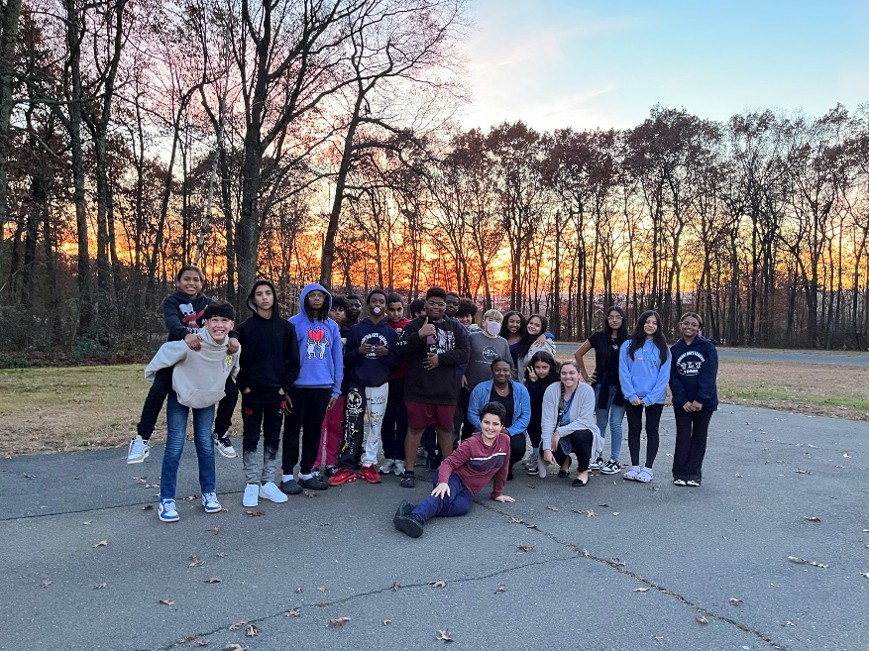

Young Women’s Issues Group
- The Young Women’s Issues Group, offered at Bristol Prep Academy began November 3rd, 2023 and has had an average of 10 students in attendance. This is a one-hour group, offered weekly and is scheduled to run through May 1st, 2024.
- Group members are encouraged to bring pressing or current topics up for group discussion in order to gain support, advice, or information to help provide solutions. To date, topics discussed have been conflict resolution, and the impact of physical altercations on the student body. As the group continues to meet, students will continue to explore issues related to young women and to discuss these issues in a confidential setting.
- Future topics will include, the impact of social media on self-image, teen dating violence, safe-sex practices, substance use and mental health through community education presenters, discussion, and activity.
- Both facilitators continue to create relationships amongst the students in the group and look forward to strengthening these connections.

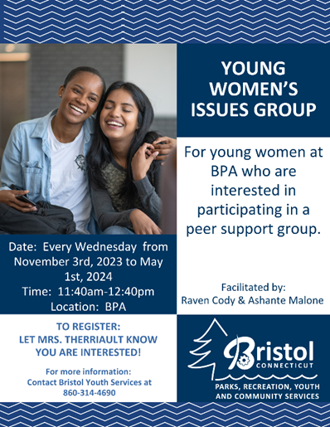

Young Men’s Issues Group

- Bristol Prep Academy’s Young Men’s Issues Group is offered weekly for one hour. While exposing the young men of the group to positive male role models who work outside of the school setting, they will be able to explore difficulties at home, difficulties at school, poor peer interactions, issues of divorced or separated parents, substance abuse, delinquency, truancy, sexual experimentation, poverty and the pressures and stereotypes associated with ‘being a man’ in today’s society in a healthy safe space.

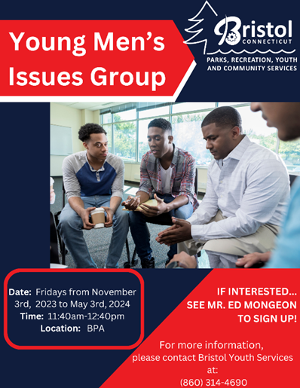

Truancy Prevention and Planning Program
- Students who have been identified as truant, or beginning to display truant behaviors, are referred to the agency by their school. Students are then paired with a Youth and Family Coordinator for a minimum of 60 days. During this time Youth and Family Coordinators work to identify blockades and hardships that may be contributing to their school absences.
- This program includes family assessments, goal creation, weekly attendance reviews, behavior monitoring, and referrals to community resources when appropriate. The truancy program aims at increasing school attendance and academic performance by working through and/or eliminating barriers that have contributed to truant behavior.
- There is currently one Truancy Prevention and Planning Program open.
